4A (1+x)^{n}
How do we Calculate nCr?
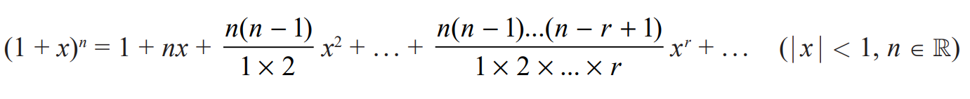

- Find: ${\left(1+x\right)}^{4}$ without using the nCr button on your calculator

- Find: ${\left(1-2x\right)}^{3}$ without using the nCr button on your calculator

When does this formula come unstuck?

- Find $\frac{1}{(1+x)}$ up to the $x^{3}$ term

- Find the Binomial expansion of: $(1-x)^{\frac{1}{3}}$ up to the $x^{3}$ term and state the values of x for which it is valid…

- Find the Binomial expansion of: $\frac{1}{(1+4x)^{2}}$ up to the $x^{3}$ term and state the values of x for which it is valid…

- Find the Binomial expansion of: $\sqrt{1-2x}$ up to the $x^{3}$ term and by using x = 0.01, find an estimate for √2

$$f\left(x\right)=\frac{2+x}{\sqrt{1+5x}}$$
- Find the $x^{2}$ term in the series expansion of $f(x)$

- State the range of values of $x$ for which the expansion is valid

- In the expansion of ${\left(1+kx\right)}^{-4}$ the coefficient of $x^{2}$ is 90, and $k>0$
- Find the value of $k$

- Find the corresponding coefficient of the $x^{3}$ term

